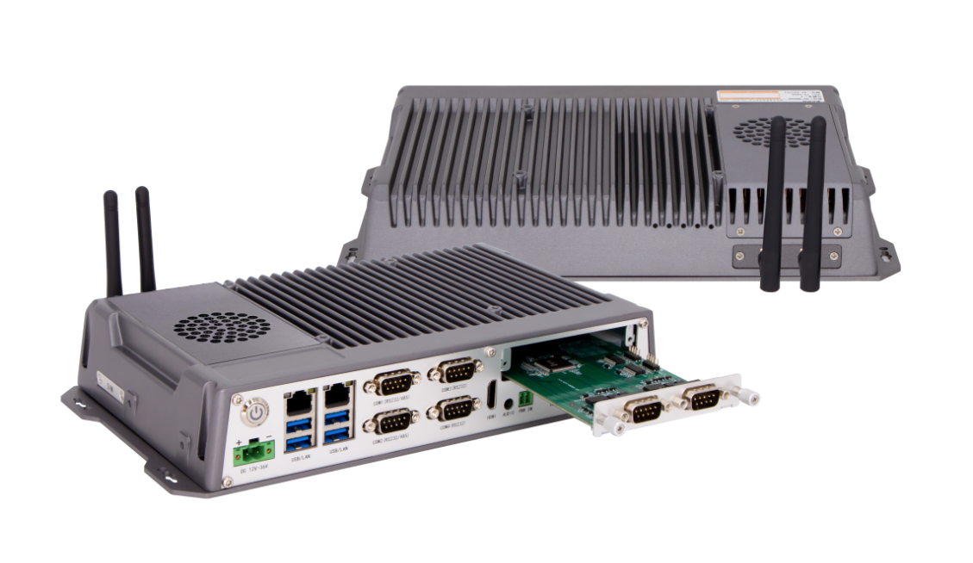
Industrial Mini PC
QY-B8000-DC
Desktop CPU Series

Products Features:
- Industrial-Grade Embedded Fanless Mini PC
- Intel B365 / H670 Chipset
- Intel Celeron, Pentium, Core 6/7/8/9/12/13/14th-i3/i5/i7/i9 CPU
- 2*LAN, 4*USB, 6*COM, 1*HDMI
- 1*Mini PCIE Expansion Slot, Support 4G/5G and WIFI Module
- 1*Multifunctional Expansion Daughter Card
- DC 9-36V Power Input With Over voltage Protection
- -30℃~70℃ Temperature Can Keep 24/7 Work Stably
- Anti-Static, Anti-Pulse, Anti-Surge, Anti-Radiation
QY-B8000-DC
1.Mother Board Specification:
Model | QY-B8000-DC
Chipset | B365 | H670
CPU | Celeron G Series  Pentium G Series  6 / 7 / 8 / 9th-i3 / i5 / i7 / i9 | Celeron G Series  Pentium G Series  12 / 13 / 14th-i3 / i5 / i7 / i9
Memory^{[1]} | 2*DDR IIII RAM Slots, Up to 64GB | 2*DDR IIII RAM Slots, Up to 128GB
Storage | 1*M.2 NVME SSD Slot | 1*M.2 NVME SSD Slot  1*MSATA SSD Slot
Display^{[2]} | 1*HDMI: Resolution up to 4096*2304@24Hz
Expansion | 1*Mini PCIE Slot, Support 4G and WIFI module | 2*M.2 Slots, Support 4G/5G and WIFI Module
Ethernet | 2*Intel i210V LAN Chip (10 / 100 / 1000 Mbps, RJ-45 Type)
USB | 4*USB 3.0 (Type-A)
COM | 2*RS-232 / 422 / 485 (DB9 Type)  4*RS-232 (DB9 Type)
Audio | 1*Line-Out
Daughter Card | Support expansion I/O interfaces and functional slots
Notes:
[1]: The maximum memory capacity and the maximum capacity per strip supported by this motherboard depend on the CPU.
[2]: The maximum resolution and frame rate of the display interface output depends on the CPU.

2.Device Specification:
QY-B8000-DC

Watch Dog | Support
Power Input | DC 9-36V With Over voltage Protection
Power Input | Support Auto-Start
Power Input | 2 Pin Phoenix Terminal Type DC Plug
Working Temperature | -30℃~70℃, Support 24/7 Working
Structure | Fully Enclosed Aluminum Alloy Material
Heat Dissipation | Fan Design
Installation | Desktop / Embedded / Wall Mount
Size | 285mm*160mm*50.5mm
System | Windows and Linux

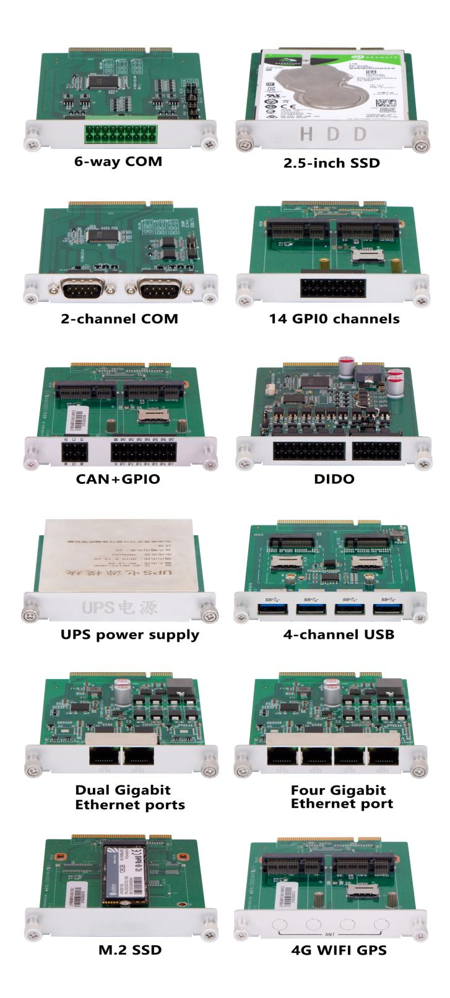
QY-B8000-DC
3.Daughter Card Specification:
COM Port-2 | 2*RS-232 / 485 (DB9 type)
COM Port-6 | 4*RS-232 / 485+2*RS-232 (Phoenix terminal type)
Ethernet Port-2 | 2*Intel i211V LAN Chip (RJ-45 type)
Ethernet Port-4 | 4*Intel i211V LAN Chip, Support POE function (RJ-45 type)
10G Ethernet Port-2 | 2*10Gbps Ethernet Ports
USB Port-4 | 4*USB 3.0 (Type-A)
GPIO Port-14 | 14 ports GPIO, 7*GPI+7*GPO, 0-3.3V (Phoenix terminal type)
DIDO Port-16 | 16 ports DIDO, 8*DI+8*DO, 24V (Phoenix terminal type)  Comes with 4*RS-485 COM ports (Phoenix terminal type)
Mini PCIE Slot-2 | 2*Mini PCIE slots, Support 4G and WIFI module
M.2 Slot-1 | 1*M.2 Key-B slot, Support 5G module
M.2 NVME SSD Slot-1 | 1*M.2 NVME SSD slot
SATA SSD Slot-1 | 1*SATA 3.0 SSD Slot, Support RAID 1
CAN Port-2 | 2*CAN interfaces (Phoenix terminal type)
UPS battery | 1.2AH or 4.8AH

QY-B8000-DC
4.Ordering Information:

Model | Chipset | LAN | USB | COM | Display | RAM | SSD | Expansion | Power
QY-B8000-DC | B365 | 2 | 4 | 2*RS-232/422/485  4*RS-232 | 1*HDMI | 2*DDR 4  Up to 64GB | 1*M.2 NVME | 1*Mini PCIE | DC 9-36V
QY-B8000-DC | H670 | 2 | 4 | 2*RS-232/422/485  4*RS-232 | 1*HDMI | 2*DDR 4  Up to 128GB | 1*M.2 NVME  1*MSATA | 2*M.2 | DC 9-36V

5.System Information:

Chipset | CPU | System
B365 | 6th / 7th | Windows 7 / 10 and Linux
B365 | Celeron G Series | Windows 10 / 11 and Linux
B365 | Pentium Gold Series | Windows 10 / 11 and Linux
B365 | 8th / 9th | Windows 10 / 11 and Linux
H670 | Celeron G Series | Windows 10 / 11 and Linux
H670 | Pentium Gold Series | Windows 10 / 11 and Linux
H670 | 12th / 13th / 14th | Windows 10 / 11 and Linux

6.Fittings Information:
QY-B8000-DC

RAM | DDR 4 | 4GB / 8GB / 16GB / 32GB
Storage | M.2 NVME | 128GB / 256GB / 512GB / 1TB / 2TB / 4TB
Storage | MSATA | 64GB / 128GB / 256GB / 512GB / 1TB
Storage | SATA | 120GB / 128GB / 240GB / 256GB / 480GB / 512GB / 960GB / 1TB / 2TB / 4TB
GSM Module | 4G | 4G+GPS
GSM Module | 5G | 5G+GPS
WIFI Module | 7260AN / 7260AC / AX210
CAN BUS | 2*CAN BUS Ports
Adapter | 1*12V 10A Adapter
Power Cable | 1*Power Cable
Terminal | 2 Pin Phoenix Terminal For Power Switch
7.Package List:

8.Dimensions:
QY-B8000-DC

